A Brief History of the Infinity Stones/Gems – Part 2 Philosophy and Ontology

By the close of 1977, the comics world saw the end of the Adam Warlock, Thanos, and the Soul Gems.  At the time, there was not a single hint that there was any future for any of these components of the Starlin mythology.  The conclusion of Thanos’s scheme to annihilate the stars with a giant synthetic Soul Gem formed from the drained essences of the six natural ones and his death at the hands of the soul of the deceased Warlock seemed definitely final.

During the intervening decade, only two small stories indicated that the flame, while sputtering and flickering, had not gone completely out.  The first came in 1980 in The Incredible Hulk #248,

[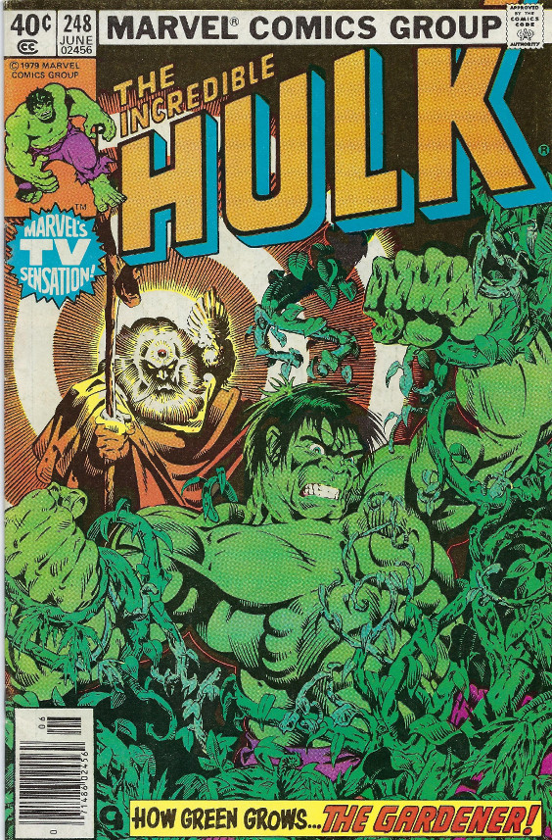](http://aboutcomics.blogwyrm.com/wp-content/uploads/2018/05/Elders_Gardener_Hulk_248.jpg)

with the reappearance of the [Gardener](https://en.wikipedia.org/wiki/Gardener_(comics)), the enigmatic Elder of the universe who once again (as seen on the cover) is sporting one of the Soul Gems.

When last seen, the Gardener had united the power of his gem with that of Adam Warlock’s to fend off an assault from the Stranger (Marvel Team-Up #55 – [see last post](http://aboutcomics.blogwyrm.com/?p=1283)).  As the Gardener relates to the Hulk, he had left his gem, which he now considered corrupted, on the moon, before his departure to ‘greener pastures’.

[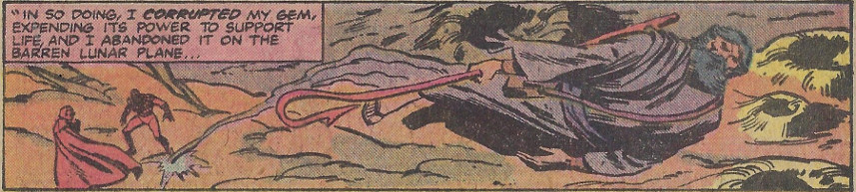](http://aboutcomics.blogwyrm.com/wp-content/uploads/2018/05/Elders_Gardener_Recaps_Hulk_248.jpg)

However, he is soon drawn back to the world of the gems, and lays claim to the Warlock’s gem from the latter’s gravesite.

[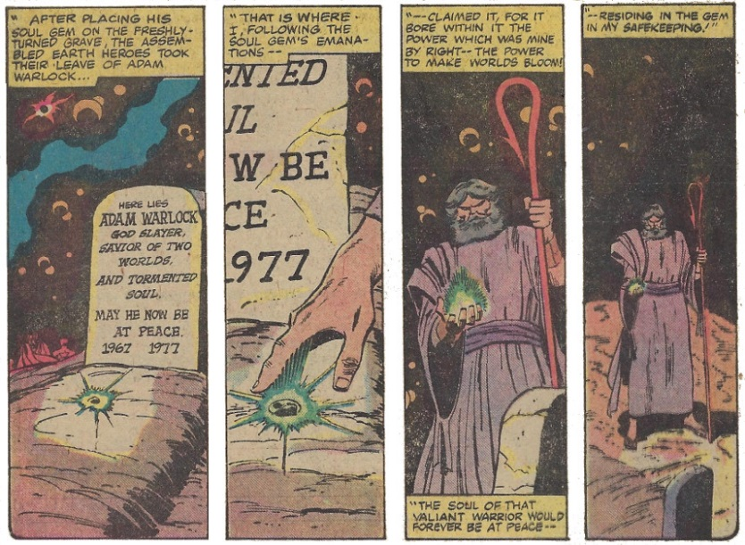](http://aboutcomics.blogwyrm.com/wp-content/uploads/2018/05/Elders_Gardener_Retrieves_Stone_Hulk_248.jpg)

The issue itself is not particularly noteworthy, and the entire story arc is contained within it.  That said, it is worth noting that Bill Mantlo was the author.  Mantlo had invented the Gardener for Marvel Team Up #55 and, perhaps, had been responsible to the idea that there were in fact 6 Soul Gems lurking out in the cosmos.

The other story was the one-shot graphic novel that Starlin did for Marvel in 1982 called The Death of Captain Marvel.  That tale was atypical of the comics world at the time as there is very little in the way of action, with the bulk of the book devoted to how various beings cope with the eminent demise of [Captain Marvel](https://en.wikipedia.org/wiki/Captain_Marvel_(Mar-Vell)) (aka the Kree warrior Mar-Vell) from untreatable cancer.  The one important aspect was a post-humous appearance of Thanos, whose attempt to destroy the universe years earlier when he took possession of the Cosmic Cube

[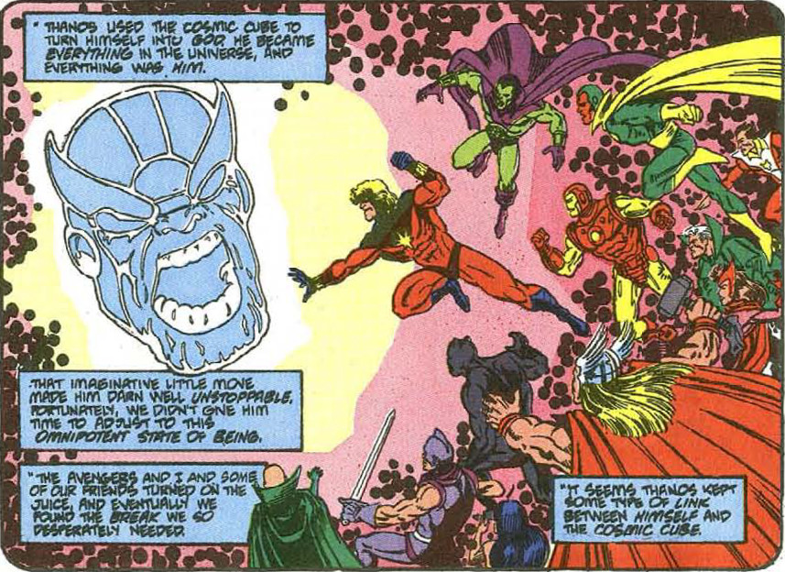](http://aboutcomics.blogwyrm.com/wp-content/uploads/2018/05/Thanos_Cosmic_Cube_Recap_SS_36.jpg)

was barely averted by Mar-vell.

[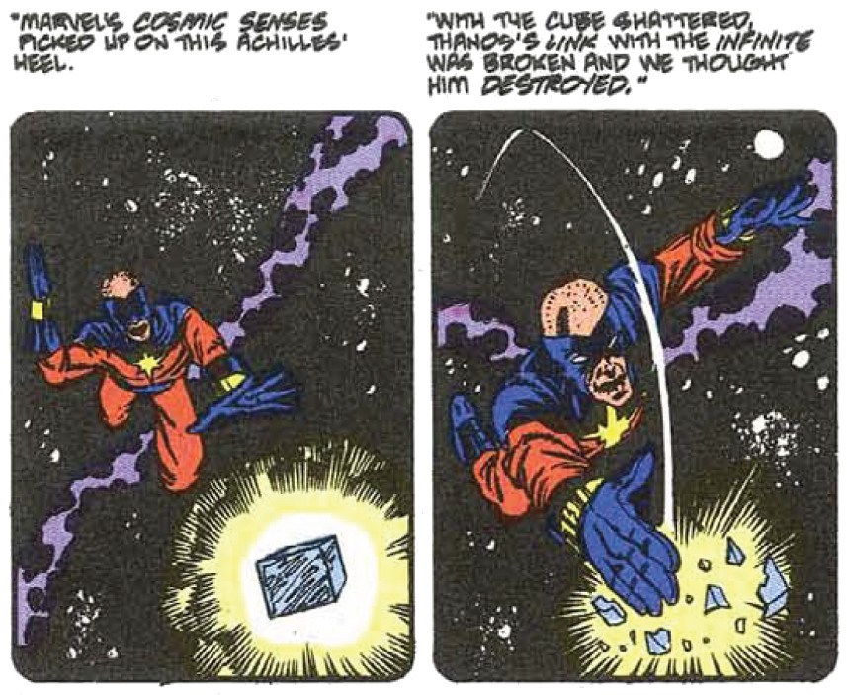](http://aboutcomics.blogwyrm.com/wp-content/uploads/2018/05/Thanos_Captain_Marvel_Stops_the_Cube_SS_36.jpg)

Death had charged Thanos, now a key member in her court (a fact that will come back later), with the responsibility of ushering Captain Marvel into her domain.

Things begin to get interesting in 1987, when Marvel began to publish the Silver Surfer as an ongoing monthly comic.  The initial writing chores fell to Steve Engelhart, who revived the Soul Gems and began to reshape the ideas behind them.  After about 3 years, the helm was turned over to Jim Starlin, who further refined the Soul Gems, eventually relabeling them the Infinity Stones as a precursor to the famous Infinity Gauntlet set of storylines.

Central to Engelhart’s approach on The Silver Surfer, was to create an ontology for the Marvel Universe that served as a backdrop to the ideas he wanted to explore and the stories he wanted to tell.  Central to this ontology was the idea of duality between [Eternity](https://en.wikipedia.org/wiki/Eternity_(comics)) and [Death](https://en.wikipedia.org/wiki/Death_(Marvel_Comics)) in the universe (here explained to the Silver Surfer and [Mantis](https://en.wikipedia.org/wiki/Mantis_(Marvel_Comics)) by the [Obliterator](https://en.wikipedia.org/wiki/Obliterator_(comics))).

[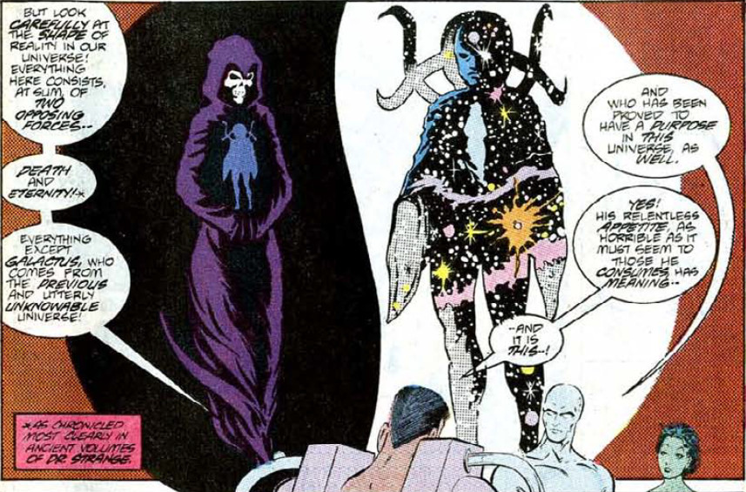](http://aboutcomics.blogwyrm.com/wp-content/uploads/2018/05/Elders_Universal_Ontology_SS_6.jpg)

[Galactus](https://en.wikipedia.org/wiki/Galactus) is the universal entity charged with both preventing stagnation between these opposing poles

[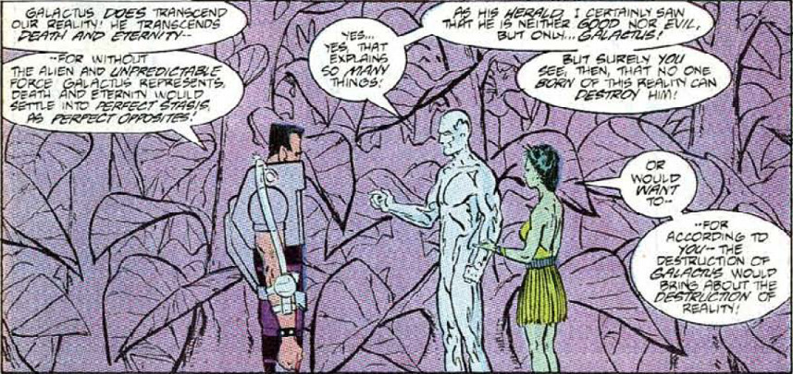](http://aboutcomics.blogwyrm.com/wp-content/uploads/2018/05/Elders_Galactus_SS_6.jpg)

and with attending to any gross imbalances that exist between the two.

[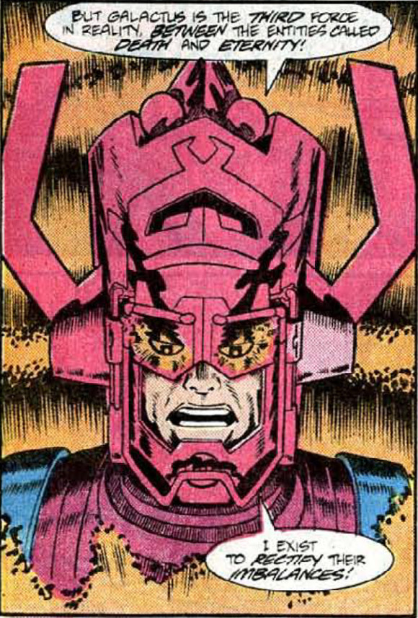](http://aboutcomics.blogwyrm.com/wp-content/uploads/2018/05/Galactus_MU_Ontology_SS_10.jpg)

The Elders, having secured immortality by maneuvering Death into refusing them entrance to her domain, realize that they have an opportunity to unseat all of reality.  Their plan is to unite the power of the Soul Gems to destroy Galactus.  With the balance gone, the universe would end and the new one that followed would then feature them as Galacti.

[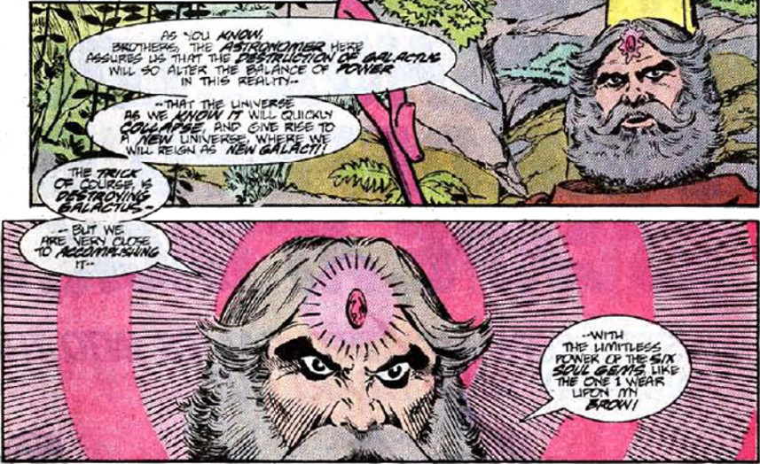](http://aboutcomics.blogwyrm.com/wp-content/uploads/2018/05/Elders_Gardener_Sports_Gem_SS_7.jpg)

It should hardly come as a surprise that Engelhart would work the Soul Gems into his grand space opus.  Under his brief stint as author of Captain Marvel, he had used a Soul Gem as a central story device (issue #46 – Sep. 1976, which predates Marvel Team-Up #55 – Mar. 1977) for an arc involving Mar-Vell and his sidekick [Rick Jones](https://en.wikipedia.org/wiki/Rick_Jones_(comics)) and their manipulation by the [Kree Supreme Intelligence](https://en.wikipedia.org/wiki/Supreme_Intelligence).

[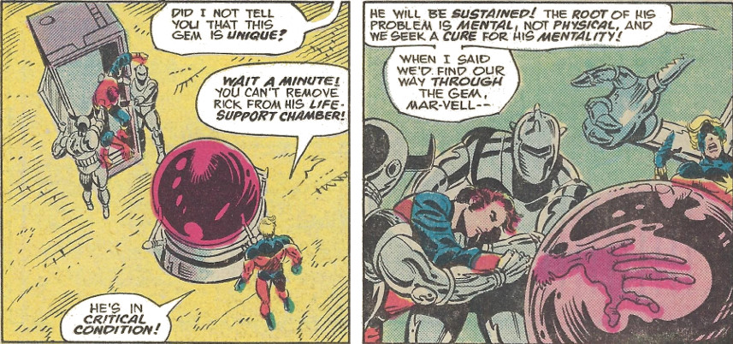](http://aboutcomics.blogwyrm.com/wp-content/uploads/2018/05/Marvel_Negatron_Head_Explains_CapMar_45.jpg)

But Engelhart expands on the unique and remarkable qualities of the Soul Gems in this go around, making them indestructible and unquenchable.

[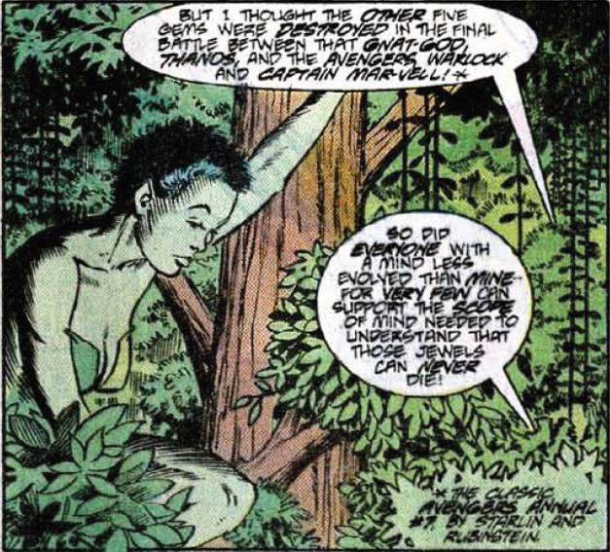](http://aboutcomics.blogwyrm.com/wp-content/uploads/2018/05/Elders_Soul_Gems_SS_7.jpg)

The Elders, already in possession of 5 of the gems, manipulate a confrontation between the Silver Surfer and the Supreme Intelligence so that the latter is force to reveal that he is in possession of the sixth gem.

[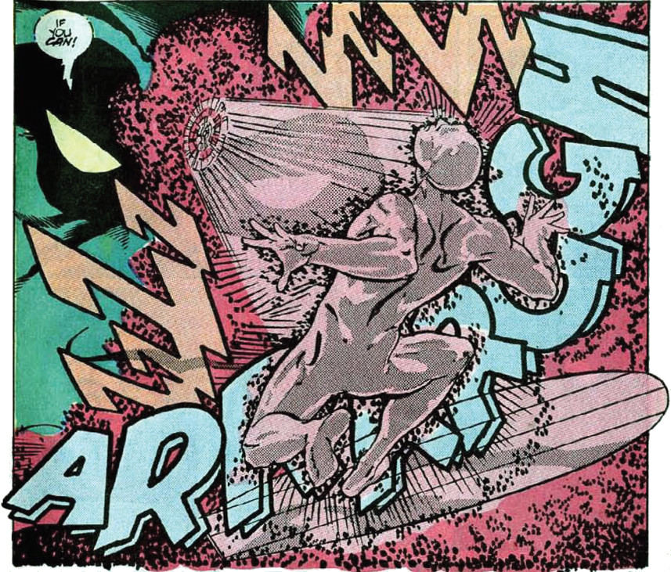](http://aboutcomics.blogwyrm.com/wp-content/uploads/2018/05/Elders_Supremor_has_a_Stone_SS_7.jpg)

This confrontation ultimately results in the Supreme Intelligence’s madness and the Elders, seizing the opportunity, also seize the last gem and begin their assault on Galactus in earnest.

[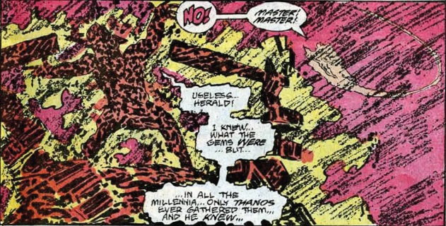](http://aboutcomics.blogwyrm.com/wp-content/uploads/2018/05/Elders_Attack_Galactus_SS_9.jpg)

Driven nearly to destruction, Galactus is only able to prevail with the help of his current herald [Nova](https://en.wikipedia.org/wiki/Nova_(Frankie_Raye)) and his former one the Silver Surfer.  He consumes some of the Elders while others are lost in the black hole that is formed during the clash.

At the end of the conflict, Galactus is revealed for what he truly is

[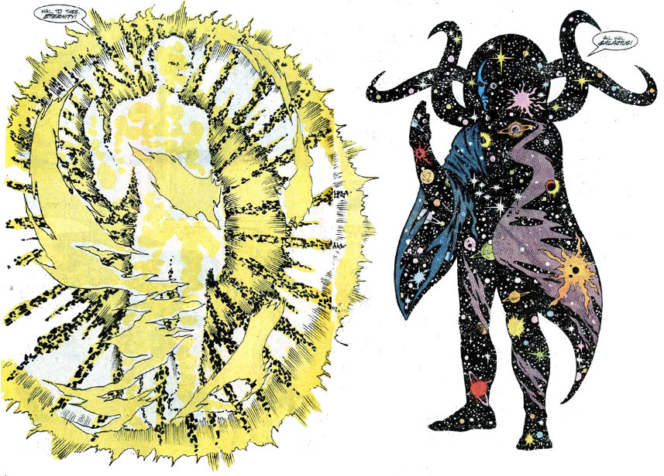](http://aboutcomics.blogwyrm.com/wp-content/uploads/2018/05/Galactus_Revealed_SS_10.jpg)

a pillar of creation.

Later in his run, Engelhart revisits the Elders and the Soul Gems again in a storyline that grafts onto his original ontology an additional dimension of dualism between order and chaos.  Under his interpretation, the black hole connects the regular universe (Eternity, Death, and Galactus) to the magical realm overseen by [Lord Chaos](https://en.wikipedia.org/wiki/Lord_Chaos_(Marvel_Comics)), [Master Order](https://en.wikipedia.org/wiki/Master_Order), and the [In-Betweener](https://en.wikipedia.org/wiki/In-Betweener) (the latter three being created by Starlin).

The In-Betweener, whose intervention indirectly led to Adam Warlock’s death at the hands of Thanos (and himself), plays the role in the magical universe that Galactus does in the conventional one.

[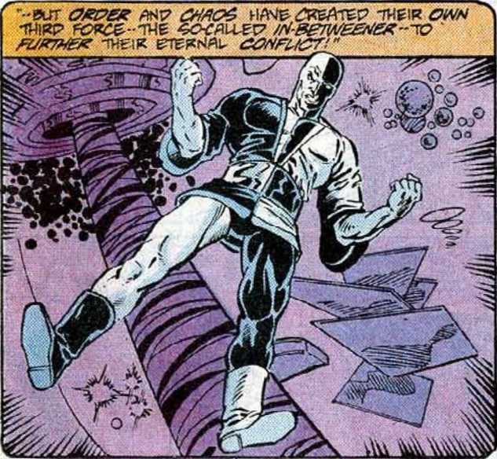](http://aboutcomics.blogwyrm.com/wp-content/uploads/2018/05/In-Betweener_MU_Ontology_SS_16.jpg)

He unites with the Elders to destroy Galactus but is defeated and imprisoned (with a gem still in his possession) in the magical realm by Lord Chaos and Master Order.

Engelhart concludes his run (Silver Surfer #31) with a revelation about dualism and the third-force between the poles delivered by none other than the [Living Tribunal](https://en.wikipedia.org/wiki/Living_Tribunal), the entity charged with overseeing all the realizations of the (Death, Eternity, Galactus) and (Lord Chaos, Master Order, In-Betweener) dualism in the Marvel multiverse.

[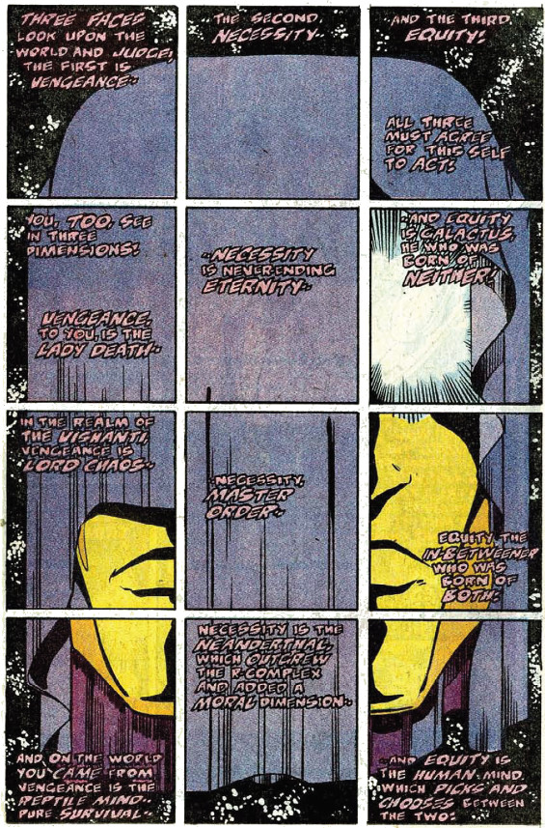](http://aboutcomics.blogwyrm.com/wp-content/uploads/2018/05/Living_Tribunal_MU_Ontology_SS_31.jpg)

Even after Engelhart’s departure, the tone of Silver Surfer remained firmly implanted in philosophy.  Jim Starlin starts with a ‘journey’ by the Silver Surfer to Death’s realm, where he sees a disembodied figure holding forth in the Dark Mistress’s court.

[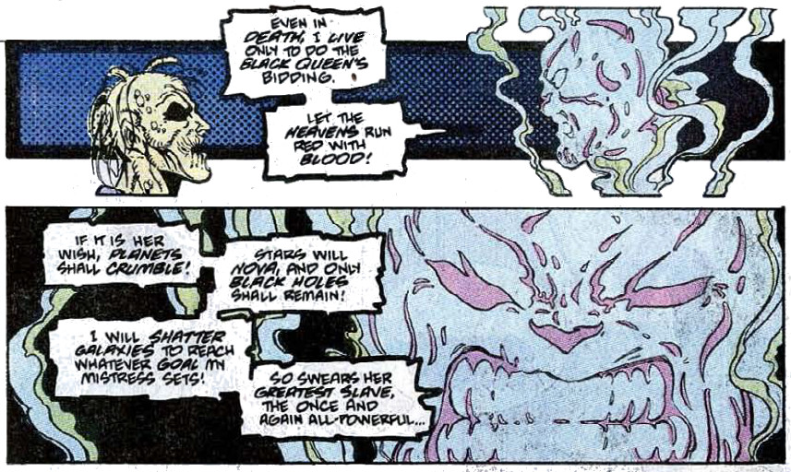](http://aboutcomics.blogwyrm.com/wp-content/uploads/2018/05/Thanos_disembodied_SS_34.jpg)

…Thanos, who is now resurrected as Death’s agent.  As the Mad Titan later explains to the Silver Surfer, thanks to the machinations of the Elders, Death became aware of problem in the universe; a problem that she has shared with members of her court, who now only speak…

[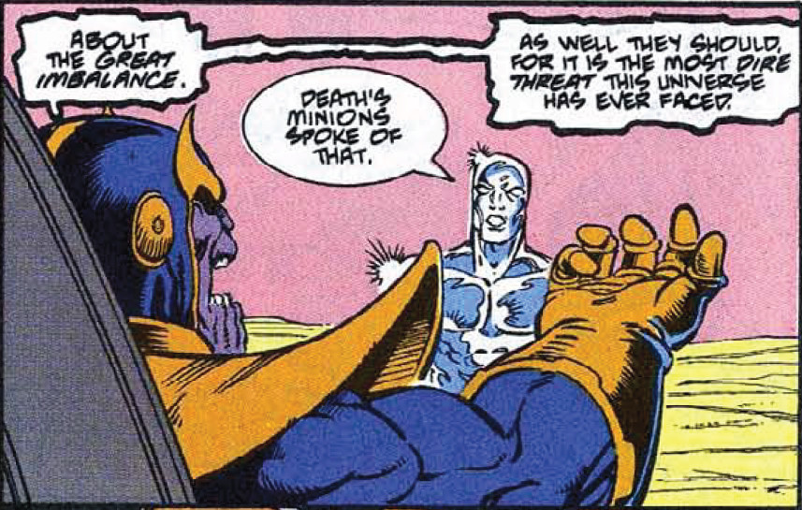](http://aboutcomics.blogwyrm.com/wp-content/uploads/2018/05/Thanos_Great_Imbalance_SS_35.jpg)

According to Death and her purple avatar, species around the universe prolong their lives beyond the limit initially granted.  They over-consume their resources, they pollute and overpopulate, and, as a result are moving life in the universe to a catastrophic end.  ‘Fortunately’, Thanos knows that the solution is

[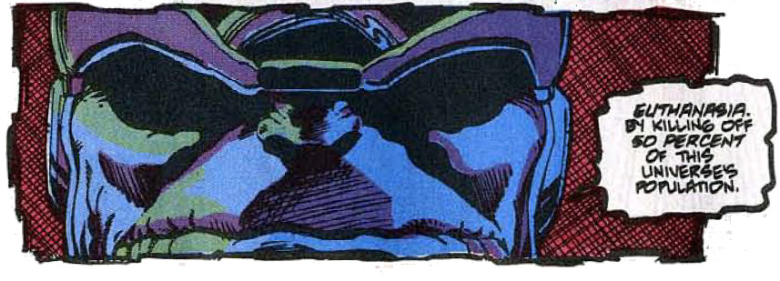](http://aboutcomics.blogwyrm.com/wp-content/uploads/2018/05/Thanos_Great_Solutions_SS_35.jpg)

Initially, the Surfer thinks this an empty boast.  Surely, Thanos can cause wide-spread mayhem (see especially issue #35), but there is no way he can eliminate half of the universe’s life.  However, research into the Titan’s past convinces the Surfer to put a stop to Thanos’s mad scheme but the results are more extreme than anticipated, with the Silver Surfer seemingly killing Thanos.

[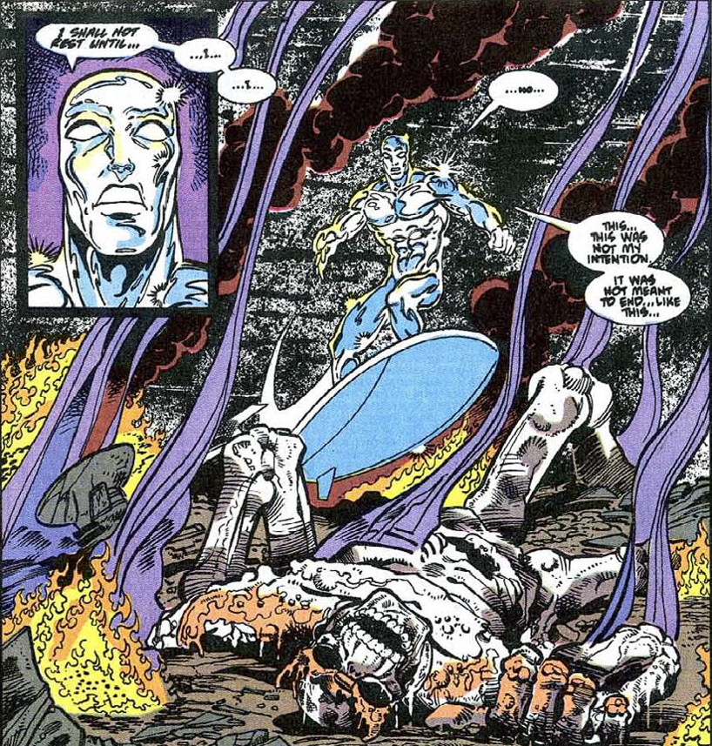](http://aboutcomics.blogwyrm.com/wp-content/uploads/2018/05/Thanos_Fakes_His_Own_Death_SS_37.jpg)

However, rumors of the Mad Titan’s demise are greatly exaggerated.  He had merely faked his death in order to retrieve the Soul Gems (soon to be renamed Infinity Gems) from the wreckage of the clash between the Elders and the In-Betweener with Galactus.  That leads directly into the Thanos Quest storyline for the next month’s post.